ORIGINAL RESEARCH PAPER / SHORT COMMUNICATION / REVIEW

TITLE OF THE PAPER
(uppercase, centered, Times New Roman 16 pt, single spaced)

John F. Doe¹, Jane N. Doe², George G. Smith^{3*}

¹University, Faculty/Department, Postal address, City, Country ²University, Faculty/Department, Postal address, City, Country ³University, Faculty/Department, Postal address, City, Country

*Corresponding author: georgesmith@mailsite.com

Received: Month, dd, yyyy
Accepted: Month, dd, yyyy

Abstract: A 15 – 20 rows abstract (Times New Roman 12 pt, justified, single spaced, Paragraph indentation: left 10 mm, right 10 mm). The abstract should be written compulsory in English. It should clearly present the aim of the work and the methods that have been used (what has been studied), the main results and the conclusions drawn on the basis of the results.
The abstract has to be clear, concise and focused on the subject. Avoid presenting general things. This abstract is taken into the databases where the paper is indexed. Think that on the quality of the abstract depends the international visibility of your work, the willing to be read and cited by other scientists.

Keywords: between 5 and 10 keywords (in English, alphabetically, lowercase, separated by commas), that will allow searching the paper under the most relevant terms. Avoid repeating in Keywords terms already used in Title

TYPES OF CONTRIBUTIONS ACCEPTED INTO THE JOURNAL

Original scientific works (6 to 16 pages), short communications (2 to 4 pages), reviews (18 to 24 pages), book reviews (1 – 2 pages), chronicles of scientific events (2 to 6 pages) are accepted. There will be not accepted memoirs, technical reports, literature compiled data with no original contributions. Excepting chronicles and book reviews, all contribution should have an even number of pages. All contributions should be written in English (preferred) or in French. Abstracts and keywords should be compulsory in English. If the paper is written in French, please provide also the title in English. For spelling and grammar please use US English and/or France French.
Original scientific works and short communications should have compulsory original findings and enough elements allowing the reproducibility of the experiments. Review articles should provide new insights and a unification of ideas concerning their subjects and should not merely be summaries of previously published papers.
Are welcomed fundamental or applicative researches in all the fields of chemistry, chemical engineering, industrial biotechnologies, food biotechnologies, environmental biotechnologies and from all the fields of food science, technology and engineering.

REVIEW PROCEDURES

Please consult the separate document entitled “Peer Review”, or access it on the web page http://pubs.ub.ro/?pg=revues&rev=cscc6&sc=review.

MANUSCRIPT PREPARATION

The manuscript should be prepared in “ready for print” form, with tables and figures included in the body text, by using the word processor from MS Office suite. Only .docx files are accepted eventually archived (.rar or .zip). Manuscripts in doc, docm or pdf format are not accepted.
Typing should be done on A4 (210 x 297 mm) forms, „portrait” oriented, with 30 mm margins on each side (top, bottom, left, right). For „Header” and „Footer” set 25 mm each. Spacing should be single lined. You may use this document as a template.
Title of the paper: Uppercase, bold, centered, font: Times New Roman (TNR) 16 pt, 60 mm below page margins. Enter one 16 pt clear line after title.
A running title (uppercase, Arial Narrow, 10 pt., blue), up to 54 characters (blanks included), in English, should be provided, to be inserted in the odd pages’ header.
Authors: Centered, bold, TNR 14 pt., in the following sequence: First name, Initial, Last name. Separate author’s names with commas (,). Do not place “and” before the last author’s name.
When authors have different affiliations, use superscripted Arabic numerals after Last name of the author. If more than one author, the corresponding author should be marked with an asterisk (*). Enter one 14 pt clear line after authors.
Affiliation: Centered, italic, TNR 14 pt., in the following sequence: University/Institution, Faculty/Department, Postal address, City, Country. Enter one 14 pt clear line after affiliation.
Corresponding author: Centered, TNR 12 pt. „*Corresponding author:” followed by e-mail address of the corresponding author. Optional, a telephone/fax number may be added, in complete format (including country area code). Enter one 12 pt clear line after corresponding author.
Priority: Centered, TNR 12 pt. „Received: Month dd, yyyy”, respectively „Accepted: Month dd, yyyy”. Data should be filled in by the publisher. Enter two clear 12 pt lines after priority.
Abstract: Justified, TNR 12 pt., paragraph indentation: left – 10 mm, right – 10 mm. Enter one 12 pt clear line after abstract. The abstract should be compulsory written in English.
Keywords: Left aligned, TNR 12 pt, italic, paragraph indentation: left – 10 mm, right – 10 mm. Enter three 12 pt clear lines after keywords. Also keywords should be compulsory written in English.
Body text: Justified, single spaced, TNR 12 pt, no paragraph indentation. It is recommended that the body text to be divided into the followings:
- Introduction;
- Materials and methods;
- Results and discussion;
- Conclusions;
- Acknowledgments (optional);
- List of notations and symbols (optional);
- References.
Introduction should not exceed 20% of the whole paper. Avoid in this section giving obvious facts, and do not divagate from the subject.

CHAPTER HEADINGS

Left aligned, TNR 12 pt., bold, uppercase, unnumbered. Before chapter heading enter two 12 pts clear lines, and after it one 12 pts clear line. A chapter may be divided in subchapters.

Subchapter headings

Left aligned, TNR 12 pt., bold, unnumbered. Before and after subchapter headings enter one 12 pts clear line. A chapter may be divided in paragraphs.

Paragraph headings
Left aligned, TNR 12 pt., bold, italic, unnumbered. Before paragraph heading enter one 12 pts clear line.

TABLES

Tables should be consecutively numbered in Arab numerals, in the order of appearance. It is recommended to keep at minimum the number of tables. It is not accepted to present the same data both in tabular and in graphical form (diagrams, graphs). All tables should have a title placed above the table. Tables should be intelligible without referring to the written text. Each table should be mentioned at least once in the text, as shown in Table 1. Place tables as closed as possible to the first citation of it. Tables should be horizontally centered and should not exceed 150 mm in width. Data and text inside table should be written in TNR 11 pts. Before and after each table enter one 12 pts clear line.

Table 1. Model for drawing a table
Characteristics | Temperature [°C]
Characteristics | 10 | 20 | 30 | 40
Characteristic A [kg·m⁻³] | xxx | xxx | xxx | xxx
Characteristic B [J·kg⁻¹·K⁻¹] | xxx | xxx | xxx | xxx
Characteristic C [mg·L⁻¹] | xxx | xxx | xxx | xxx

FIGURES

All illustrations (graphs, schemes, diagrams, pictures, etc.) should be named as Figures. Figures should be consecutively numbered in Arab numerals, in the order of appearance. All figures should have a title placed below the figure. Each figure should be mentioned at least once in the text, as shown in Figure 1. Figures should be inscriptioned in TNR 10 – 12 pts, in such manner that visibility of text can be assured. Place figures as closed as possible to the first citation of it. Grouping figures two in a row (inserted in a table with hidden lines) is recommended (Figures 2 and 3). Figures drawn directly into the Word document are forbidden. They should be imported as images (jpg, bmp, tiff) or as objects (ppt). Only black & white images of high contrast should be used (Fig. 3). In graphs and charts, curves should be identified by using different symbols for points (•, ◊, ○, □, ■, ▲, etc.) and not by line width or color (Figure 2).
Do not place figures into bordered frames. Do not border the graphs, diagrams, illustrations. It is recommended to keep at minimum the number of figures. Before and after each figure enter one 12 pts clear line. The text into the figures should be written in the same language as the body text. It is not allowed that the paper to be written in French, and the text of the figures to be in English.

EQUATIONS

Equations should be written centered on the page, and consecutively numbered in Arab numerals between round brackets at the right margin of the paper. Above and below the equation enter a 3 pts clear line, as observed at eqn. (1):
(1)
Equations should be written by using the equation editor included in MS Word program, with the following size of characters: Full = 12 pt; Subscript/Superscript = 7 pt; Sub-subscript/Superscript = 5 pt; Symbol = 18 pt; Sub-symbol = 12 pt. Variables in equations should be in italics.

Figure 1. Model for inserting a reaction scheme

 | 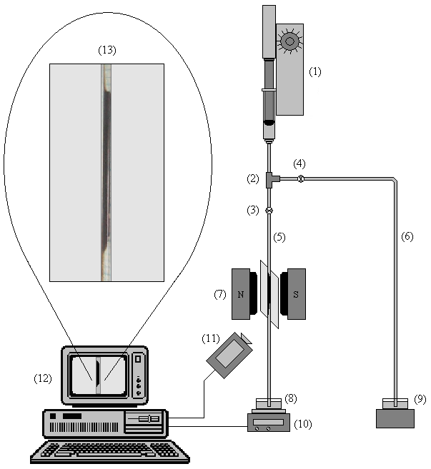
Figure 2. Model for inserting a graph | Figure 3. Model for inserting an experimental device scheme

SYMBOLS, NOTATIONS AND MEASUREMENT UNITS

Symbols and notations unanimously international accepted should be used. Each notation should be explained where it first appears, unless there is a separate “List of notations”. Abbreviations should be also explained at their first appearance. Authors are recommended to employ the metric units and the SI system. Use capital L for Liter, in order to avoid confusions. For “kilo” use “k” and not “K” as a symbol. It is preferred to write the measurement units as “J·kg⁻¹·K⁻¹” and not “J/kg/K” or “J/kg.K” or “J/(kg.K)”.

REFERENCES

Citations in text should be made with Arab numerals in square brackets. References should be listed in order of citation. All literature listed in the “References” section must be cited at least once. More than two sources cited once should be spelled [5 – 8] and not [5, 6, 7, 8] or [5], [6], [7], [8] or [5 a, b, c, d].
Reference list should be written in TNR 10 pts, left-aligned, numbered list, as in the model below. Standard citations for books [1], author chapters in books [2], journal published papers [3], “Proceedings” published papers [4], patents [5], websites [6], are as follows:

- Atkins, P.W.: Physical Chemistry, 4th edition, Oxford University Press, Oxford, 1990, 249-252;
- Karlsson, R., Rydén, L: Ion Exchange Chromatography in: Protein Purification – Principles, High Resolution Methods, and Applications (Editors: Janson, J.-C., Rydén, L.), VCH Publishers, New York, 1989, 26-127;
- Morais Barros, A.J., Prasad, S., Duarte Leite, V., Gouveia Souza, A.: The Process of Biosorption of Heavy Metals in Bioreactors Loaded with Sanitary Sewage Sludge, Brazilian Journal of Chemical Engineering, 2006, 23 (2), 153-162;
- Douay, F., Pruvot, C., Dubourguier, H.C., François, M., Sterckeman, T., Ciesielski, H.: Comportement physico-chimique et transfert des métaux lourds vers l’hydrosphère et la biosphère autour de deux usines métallurgiques du nord de la France in: Actes du deuxième Colloque Franco-Roumain de Chimie Appliquée COFrRoCA – 2002 (Editors: Gavrilă, L., Fînaru, A., Grandclaudon, P.), Ed. Alma Mater Bacău, Ed. Tehnica-Info Chişinău, 2002, 321-324;
- Smith, J.: U.S. Patent 8,143,241, 1998;
- http://pubs.ub.ro/?pg=revues&rev=cscc6&sc=instructions, Instructions for Authors, accessed October 11, 2010.

Note in the references section: The full journal name should be written, abbreviations are not allowed!

